Database Management System 2024

Project Brief

1. Project Idea:

This project shows an inventory management system designed for small to mid-sized stores. It provides a user-friendly interface to manage products, customers, suppliers, users, and transactions.

1. Project Demonstration
   * Introduction to Project:

This is an Inventory Management System built with a MySQL database for data storage.

* + Problem statement:

Manual inventory management can be time consuming and make errors for small businesses. This system aims to program tasks and simplify inventory tracking.

* + Methodology (technology along with complete code):

MySQL (Database)

MySQL Workbench (Database Management)

* + Results and conclusion (testing, evaluating model, remarks):

The application has been tested for basic functionalities like adding, editing, and deleting products, customers, and suppliers. It also manages sales and purchase transactions. Further testing and feature enhancements are planned.

**ER DIAGRAM OF INVENTORY SYSTEM**

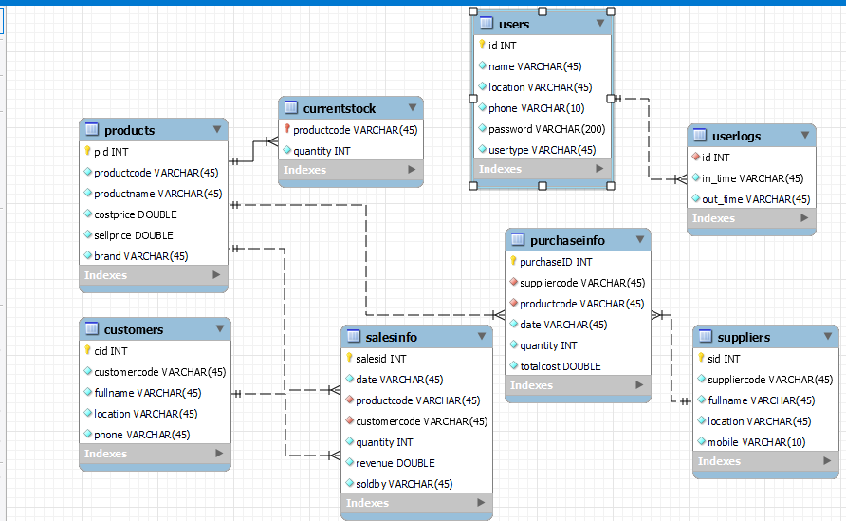

The above ER diagram represents the relationships between the entities in the inventory management system. Each entity is connected based on how they interact with each other.

**Entities and Attributes**

**Products Table**

Attributes: Product ID(Primary Key),Product Code (UNIQUE),Product Name(Unique), Cost Price, Sell Price, Brand

**Current Stock Table:**

Attributes: Product Code (Primary Key), Quantity (Not null)

**Customers Table:**

Attributes: Customer ID (Primary Key), Customer code (Unique), Full Name (not null), Location, Phone

**Suppliers Table:**

Attributes: Supplier ID (Primary Key), Full Name, Location, Mobile

**Purchase Info Table:**

Attributes: Purchase ID (Primary key), Supplier Code (Foreign Key), Product Code(Foreign Key, Date, Quantity, Total Cost

**Sales Info Table:**

Attributes: Sales ID(P.K), Date, Product Code(F.K), Customer Code(F.K), Quantity, Revenue, Sold By

**Users Table:**

Attributes: ID(P.K), Name, Location, Phone, Password, User Type

**User Logs Table:**

Attributes: ID(F.K), In Time, Out Time

**Logical design:**

When a product is purchased, a record is added to Purchase Info, and the quantity purchased is updated in Current Stock.

When a product is sold, a record is added to Sales Info, and the quantity sold is deducted from Current Stock.

Users can log in and out, and their activity is recorded in User Logs.

Different types of users (such as administrators and employees) have different access levels and privileges.

Queries:

1. Find the number of customers in each location.

* select location, COUNT(*) as number_of_customers from customers GROUP BY location;

1. Find the minimum and maximum sell prices of products.

* select MIN(sellprice) as min_sell_price, MAX(sellprice) as max_sell_price from products;

1. Find the names of customers who purchased each product.

* select p.productname, c.fullname from salesinfo s JOIN products p ON s.productcode = p.productcode JOIN customers c ON s.customercode = c.customercode;

1. list all suppliers and the total cost of products they have supplied.

* select fullname, (select SUM(totalcost) from purchaseinfo where suppliercode = s.suppliercode) AS total_cost_supplied from suppliers s;

1. Write a query to return the user's name, location, phone number, and login time.

* select users.name, users.location, users.phone, userlogs.in_time from users INNER JOIN userlogs ON users.id = userlogs.id;

Github repository access: